Joint Visit - Seminar
The Future of Posting: Third Country Nationals in the Spotlight
23 September 2019 Vienna, Austria

13:00 Registration
13:30 Opening Remarks
Anette Scoppetta, European Centre for Social Welfare Policy and Research
13:45 – 15:00 Posting and Third Country Posting: The Austrian experience
Sonila Danaj, European Centre for Social Welfare Policy and Research
Johannes Peyrl, ArbeiterKammer Wien
15:00 – 15:15 Coffee Break
15:15 – 16:30 The EU institutions and social partners’ perspective on posting
Federico Pancaldi, European Commission
Werner Buelen, European Federation of Building and Woodworkers
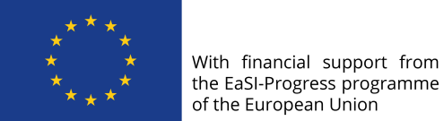
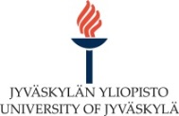
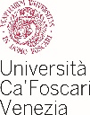
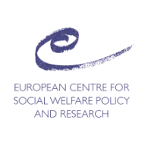
16:30 – 16:45 Wrap up and next steps

